**Pocket money**

**Problem**  
Sally and David have agreed to work for their mother over the holidays. The pay they get will vary though. Sally will get £10 for the first day she works and two more pounds for every day she works after that. David, on the other hand, will get £1 for the first day he works but for each day he works from then on his pay will be doubled. Who would you rather be and why?

**Legs in the Barn**

**Problem**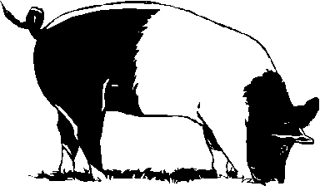  
One third of the animals in the barn are chickens. The rest are pigs. There are 20 legs in all. How many pigs are there?

**At The Movies**

**Problem**  
John, Jo and Chris have got seats for the pictures. In fact their seats are F5, F6, F7. In how many ways can they sit in those seats?

**The Fathers’ Day Card**

**Problem**  
Lee and Jamie have decided to buy their father a card for Fathers’ Day. The card is going to cost £5.95. Lee puts in 35p more than Jamie. How much does each child contribute to the card?

**My Dogs**

**Problem **  
I have three dogs of different ages. If I add their ages together I get 15. If I multiply their ages together I get 45. How old are my dogs?

**Super Darts**

**Problem**   
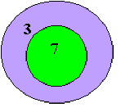Jetta has just been given a dart game for her birthday. The board has an outer ring and an inner ring. The outer ring scores 3 points and the inner ring 7. Jetta was bored with only using three darts . She wondered if she used as many darts as she liked whether she could get 58 points.

Can she get 58? If so, in how many ways can she get 58?

(If she can’t get 58 find a number in the 50s that she can get and see how many times she can get that number.)

**Darts Game**

**Problem**   
Jetta has just been given a dart game for her birthday. The board has an outer ring and an inner ring. The outer ring scores 3 points and the inner ring 7. The game has three darts.

1. ****What scores can Jetta get?
2. Jetta thought that was a bit boring so she decided that she could add and subtract the 3s and 7s. What possible positive scores could she get now?
3. What whole numbers can Jetta get if she is allowed to use any of the four operations of addition, subtraction, multiplication and division?

**Even More Pizzas And Things**

**Problem**  
The Pizza Place has 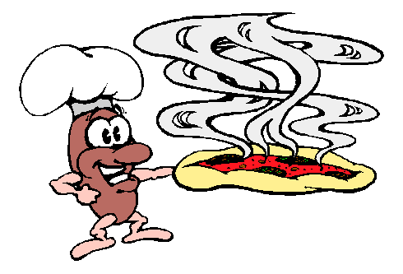three tables. The biggest one seats three times as many people as the smallest one. The middle sized table seats twice as many people as the smallest one.

On Tuesday night three-quarters of the seats were taken. Then twelve more people arrived. Unfortunately there were only enough seats for half of them.

How many people can sit at the smallest table?

**Gulls**

**Problem**  
It has been raining. In the paddock near the school 273 worms have come to the surface.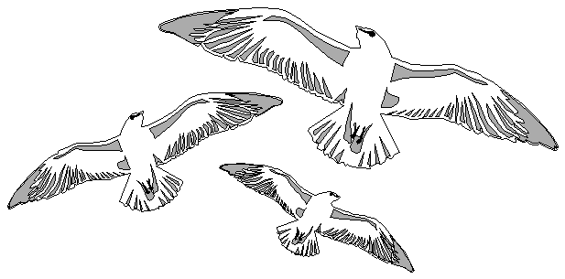 As you can imagine, the seagulls have started to hover overhead.

1. Now gulls are satisfied if they can eat 11 worms in one sitting. How many gulls can be satisfied by the worms in the paddock?
2. Actually gulls can ‘drum up’ worms by ‘running on the spot’. Have you seen them doing that? A flock of 34 gulls lands in the paddock with 273 worms. How many worms will they have to drum up so that they are all satisfied?
3. In another paddock there are 359 worms. After another flock lands there and has drummed up enough worms, each gull can be satisfied. What’s more, the leader of the flock manages to get two extra worms. How many gulls were there in this flock?

**The Rock Pool**

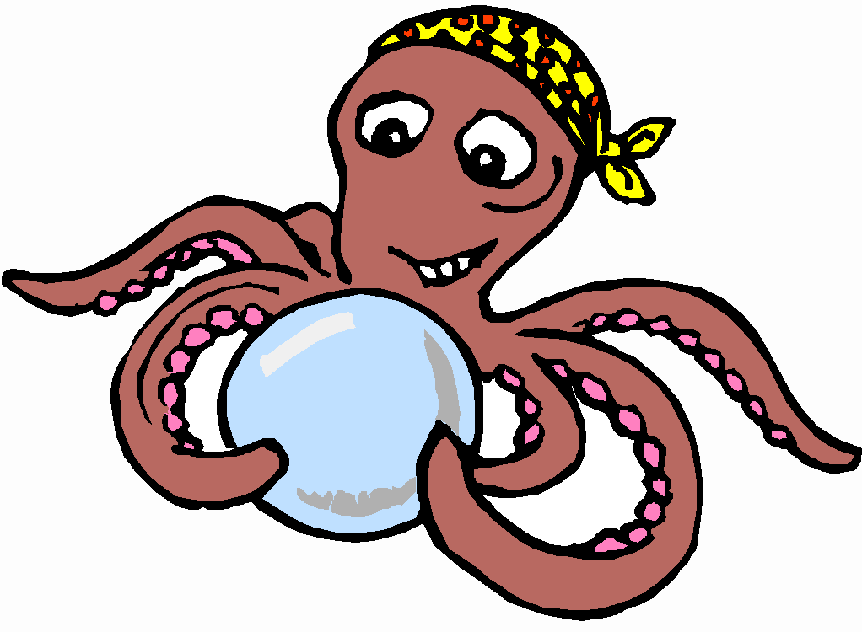Some octopuses, some fish and a few mermaids were happily frolicking in a rock pool. Altogether there were 38 arms, 24 eyes and 8 tails all swimming in the pool.

How many mermaids were there?

**Lollies, Lollies, Lollies**

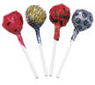**Problem**  
On Monday, Sam, Sunny and Sylvia shared some lollies that their mother had given them. Sunny got twice as many lollies as Sam. Sylvia got three times as many lollies as Sam.

Their mother gave them the same number of lollies each day up to (and including) Friday. If Sylvia got a total of 18 lollies on Tuesday and Wednesday, how many lollies did Sunny get for the whole five days?

How many lollies would Sam need to get on Saturday if he wanted to have 39 lollies altogether?

**Triangular Numbers**

**Problem**Triangular numbers are made by forming triangular patterns with counters. Riwa has made the first four triangular numbers with blue counters.

|  |
| --- |
| TriangularNumbers |

Riwa didn’t think that the first triangular number really looked like a triangle but it seemed a good place for the pattern to start. The first triangular number is made with just one counter and so is one. The second triangular number is 3. The 3rd triangular number is 6 and the 4th triangular number is 10.

What is the 10th triangular number?

What is the 20th triangular number?